NAME OF ASSOCIATION/CLUB OR SOCIETY: North Sydney Student Paramedic Association
Event | STUCON Conference Viewing |  | Location |  |  | ACU North Sydney Campus
Event Coordinator(s) | Alex Hook, Felicity Bryder, Lachlan Beattie, Rena Zhu |  | Date &Time of Event |  |  | 30/07/21 – 09:00-16:00
Assessment Completed by | Lachlan Beattie |  | Date prepared |  |  | 05/07/21
INCIDENT CONTACT LIST – In case of an emergency call 000 and notify staff at the event / call 8888 (ACU Campus Security) or 1300 729 452.
The Student Enrichment Adviser or staff member (present at the event) will notify the Manager, Student Enrichment.
If a staff member is not at the event, the event coordinator must contact the Manager, Student Enrichment.
In the case of any other incident that does not require emergency services, the local Student Enrichment staff / event coordinator must report the matter to the Manger, Student Enrichment.
TITLE |  | NAME |  |  | CONTACT NUMBER
Event Coordinator(s) |  | Alex Hook  Lachlan Beattie |  |  | 0403 053 759
Felicity Bryder
Rena Zhu
RSA Certificates –current certificate must be attached with this RA |  | N/A
 |  | N/A
Student Life Officer |  | Michael Boateng Benson
Campus Security |  | 8888 (1300 729 452)
First Aid Officer |  | 8888 (1300 729 452)  or visit http://www.acu.edu.au/policy/169133 to access staff First Aid Officers
Manager Student Enrichment |  | Michael Boateng Benson |  | +61 2 9739 2877
Emergency Services, Fire Ambulance or Police |  | Emergency |  | 000
If Student Enrichment Adviser or Student Enrichment Manager cannot be contacted report Incident immediately to:
ACU National Security Centre (NSC) on 8888 or 1300 729 452
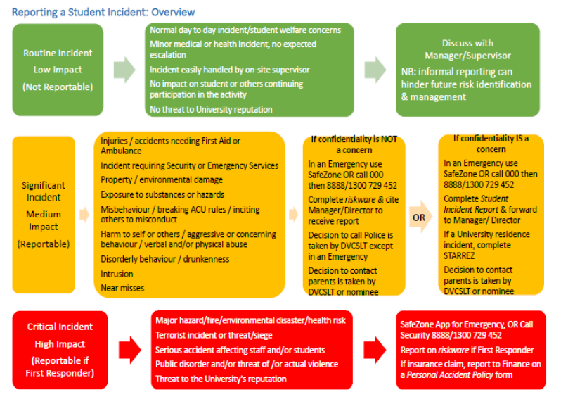

How to use this tool to Assess and Manage Risks Associated with the Event/Activity
Use this plan to assess the threats (something that could cause harm to people and/or property), listed within this Risk Assessment and Control Action Plan, for risk and develop treatments to manage these risks. During this process, consider consulting with subject matter experts to assess risk and develop treatments. You should also consult with anyone that would apply the treatments that are developed as these people will be responsible for implementing these actions.
Step 1: Assess each threat, which is listed in this plan, and enter any existing treatments (controls) that you apply to manage risk into column 4 (Page 4 to 9). The treatments that are listed in this plan should also include the actions that will be taken to mitigate the risk if the threat does occur.
Step 2: Assess the risk rating, using the Risk Rating Table in Appendix A, which is associated with applying these existing treatments to manage the risk.
The Risk Rating Table prompts you to assess the likelihood of the threat and consequence of the risk occurring. The intersection point between this likelihood and consequence rating = the Risk Rating for the threat.
Step 3: If the Risk of harm to people for a threat is higher than Medium (3) consider developing additional treatments to reduce the Risk Rating.
Step 4: Reassess the Risk Rating, based on applying existing and new treatments, and keep applying treatments until the risk is reduced down to a manageable level.
Step 5: In the last column, list the Action Owner that will be responsible for implementing the treatments.
Step 6: Submit the completed Risk Assessment and Control Action Plan to your Student Enrichment Adviser for endorsement and retain a copy for your records.
Step 7: Ensure that other people involved in overseeing aspects of the event are fully briefed about the risks identified and treatments and apply these strategies during the activity.

 | Threats |  | Risk Assessment |  | Action
 |  | What harm can happen to people or equipment? | List treatments that have already implemented | Risk Rating  (if the rating is higher than Moderate 3, apply more treatments) | Action Required by Whom
Drunk & Disorderly | 1 | Drinking to excess that has caused intoxication | There will be no alcohol supplied | Rare | No action required
Drunk & Disorderly | 2 | Drink Spiking | Open cup drinks will not be provided  Drug affected students will be asked to leave and if health concerns raised, 000 called | Rare | Campus security contacted by event coordinators  000 rang by event coordinators

 | Threats |  | Risk Assessment |  | Action
 |  | What harm can happen to people or equipment? | List treatments that have already implemented | Risk Rating  (if the rating is higher than Moderate 3, apply more treatments) | Action Required by Whom
Property Damage | 3 | Damage to venue furniture | Students have had the consequences explained if there is unsociable or destructive behaviour  Campus security will be utilised in the event of venue damage | Unlikely | Campus security contacted by event coordinators
Property Damage | 4 | Participation in criminal offence such as arson | Students have had the consequences explained if there is unsociable or destructive behaviour  Campus security will also be utilised in the event of arson | Unlikely | Campus security contacted by event coordinators

 | Threats |  | Risk Assessment |  | Action
 |  | What harm can happen to people or equipment? | List treatments that have already implemented | Risk Rating  (if the rating is higher than Moderate 3, apply more treatments) | Action Required by Whom
Theft | 5 | Monies or valuables stolen from another person | There should be no reason for students to leave valuables unattended.  Students still however encouraged to care for valuables.  Campus security available if necessary | Unlikely | Campus security contacted by event coordinators
Motor Accident | 6 | Car Accident | As the event is run within a classroom there is no risk of car accident during the event. | Rare | No action required

 | Threats |  | Risk Assessment |  | Action
 |  | What harm can happen to people or equipment? | List treatments that have already implemented | Risk Rating  (if the rating is higher than Moderate 3, apply more treatments) | Action Required by Whom
Assault | 7 | Sexual Assault/Rape | Campus security available in the event of sexual assault or rape.  000 also will be contacted. | Rare | Campus security contacted by event coordinators  000 contacted by event coordinators
Drugs | 8 | Identify possession of drugs | Students reminded of consequences of illicit substances on campus at the event.  Campus security contacted in the event of this. | Rare | Campus security contacted by event coordinators
Drugs | 9 | Use of Drugs | Students will be removed from event and campus security contacted if this occurs | Rare | Campus security contacted by event coordinators
 | Threats |  | Risk Assessment |  | Action
 |  | What harm can happen to people or equipment? | List treatments that have already implemented | Risk Rating  (if the rating is higher than Moderate 3, apply more treatments) | Action Required by Whom
Suicide | 10 | Suicide attempts | Medical assistance will be sought.  000 to be called in the event of attempted suicide. | Rare | Campus security contacted by event coordinators  000 contacted by event coordinators
Allergic Reaction | 11 | Reaction to food items | As the event is on campus, ACU first aid staff should be available.  In the event they are not, 000 will be called. | Unlikely | Campus security contacted by event coordinators  000 contacted by event coordinators
 | Threats |  | Risk Assessment |  | Action
 |  | What harm can happen to people or equipment? | List treatments that have already implemented | Risk Rating  (if the rating is higher than Moderate 3, apply more treatments) | Action Required by Whom
Weather | 12 | Weather | Event will be run indoors with no weather requirements | Rare | No action required
Financial | 13 | Financial loss/fraud e.g. less than expected ticket sales and/or theft of income from sales | Event is free of charge to the society and all sales made will be a profit | Rare | No action required

Appendix A –Risk Rating Table How to calculate your risk score, using the scales in the table below:
Step 1: Assess the likelihood of the threat occurring (ratings between Rare to Almost Certain)
Step 2: Assess the likely consequence of the threat occurring (from Insignificant to Catastrophic)
Step 3: Identify the intersection point (on the table below) of the likelihood and consequence rating to obtain a Risk Rating.
Step 4: If the Risk Rating is higher than Medium (3) - especially if the threat could cause harm -continue to develop other treatments to reduce the risk.
Likelihood Ratings |  | Consequence Ratings
Almost Certain: Is expected to occur in most circumstances per month)  Likely: Will probably occur at least once (between once per month and once per year)  Moderate: Might occur at some time (between once per year and once in 5 years)  Unlikely: Could occur at some time (between once in 5 years and once in 20 years)  Rare: May occur in exceptional circumstances (once in moe than 20 years) |  | Catastrophic: Could result in death, permanent total disabilities or severe injuries affecting multiple persons  Major: Could result in permanent partial disabilities or injuries or illness resulting in hospitalisation of multiple persons  Moderate: Could result in injury or illness resulting  Minor: Minor injury or illness Insignificant: Unlikely to result in an injury
Likelihood  Rating  (values on vertical axis, below) | Consequence Rating Insignificant/Minor/Moderate/Major/Catastrophic)
Likelihood  Rating  (values on vertical axis, below) | (
Likelihood  Rating  (values on vertical axis, below) | Insignificant (1) | Minor  (3) | Moderate (10) | Major (30) | Catastrophic (100)
Almost Certain  (3) | Moderate 3 | Moderate 9 | High 30 | High 90 | High 300
Likely  (1) | Moderate 1  1 | Moderate 3 | Moderate 10 | High 30 | High 100
Moderate  (0.3) | Low 0.3 | Moderate 0.9 | Moderate 3 | Moderate 9 | High 30
Unlikely  (0.1) | Low 0.1 | Low 0.3 | Moderate 1 | Moderate 3 | Moderate 10
Rare  (0.03) | Low 0.03 | Low 0.09 | Low 0.3 | Moderate 0.9 | Moderate 3

