STUDENT LIFE – OFFICE OF STUDENT SUCCESS
Event name & type | Signadou Queer Society AGM |  | Location |  |  | 300.G.35
Event Coordinator(s) | Kristen Bosio |  | Date &Time of Event |  |  | October 25, 2024, 4pm
Event Manager(s) | Kristen Bosio
Assessment Completed by | Kristen Bosio |  | Date prepared |  |  | October 8, 2026
INCIDENT CONTACT LIST – In case of an emergency call 000 and notify staff at the event / call 8888 (ACU Campus Security) or 1300 729 452.
In the event of any incident the event manager will notify their supervisor. If they cannot contact their supervisor they should contact the next person in the hierarchy.
If Student Life Officer or Student Life Manager cannot be contacted report Incident immediately to:
ACU National Security Centre (NSC) on 8888 or 1300 729 452
TITLE |  | NAME |  |  | CONTACT NUMBER
Event Coordinator(s) |  | Kristen Bosio |  |  | 0409464568
Student Life Officer |  | N/A currently National Manager as below
Event Security provided by (if applicable) |  | Campus Security as normal
First Aid Officer (if applicable) |  | NA
Designated non-drinker (if applicable) |  | NA
National Manager Student Life |  | Alistair Cowie |  | 0426 833 479
Emergency Services, Fire Ambulance or Police |  | Emergency |  | 000
If Student Life Officer or Student Life Manager cannot be contacted report Incident immediately to:
ACU National Security Centre (NSC) on 8888 or 1300 729 452
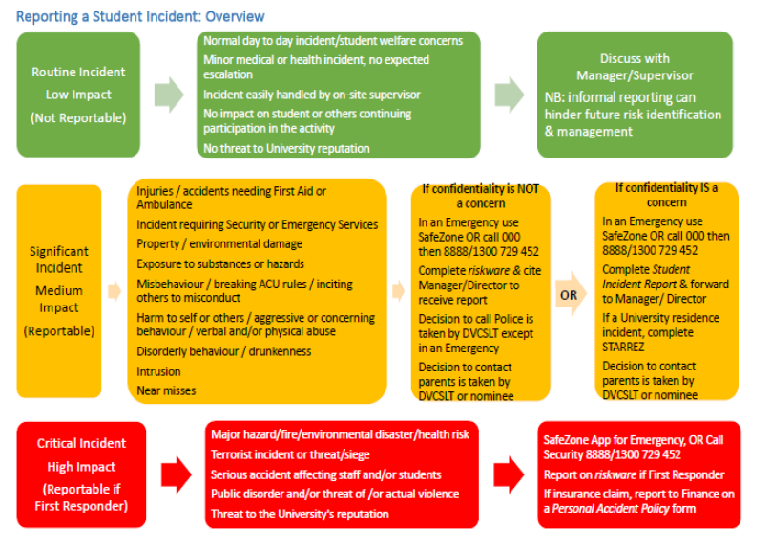

How to use this tool to assess and manage risks associated with the event/activity
Use this plan to assess the threats (i.e. something that could cause harm to people and/or property), listed within this Risk Assessment and Control Action Plan and develop treatments to manage these risks. During this process, consider consulting with subject matter experts to assess risk and develop treatments. You should also consult with anyone who might apply the treatments that are developed as they may be responsible for implementing the actions.

Step 1: Create a list of all the threats associated with your event. (Use the table on P5 to assist in this process).
Step 2. Transfer that list to Column 1 in the Risk Assessment and Control Action Plan Table(Page 6).
Step 3 Assess each threat listed in the plan and record any existing treatments (controls) that already apply to manage the risk into Column 3 of the Table. (Page 6). The treatments that are listed in this plan should also include the actions that will be taken to mitigate the risk if the threat does occur.
Step 4: Assess the risk rating, using the Risk Rating Matrix (Appendix A). The Matrix prompts you to assess the likelihood of the threat and consequence of the risk occurring. The intersection point between this likelihood and consequence rating = the Risk Rating for the threat.
Step 5: If the risk of harm to people for a threat is higher than Medium consider developing additional treatments to reduce the risk rating and add those to Column 5 of the Table (Page 6).
Step 6: Reassess the risk rating, based on applying existing and new treatments, and keep applying treatments until the risk is reduced down to a manageable level and enter the revised risk rating in Column 6 of the Table (Page 6).
Step 7: Submit the completed Risk Assessment and Control Action Plan to your supervisor for endorsement and retain a copy for your records.
Step 8: Ensure that other people involved in overseeing aspects of the event are fully briefed about the risks identified and treatments so that they may be applied during the activities.

Things to consider
These are just thought starters… you should consider what might go wrong at any stage of every event.
- Location / Environmental factors  - Drowning (e.g. harbour cruises, swimming parties)  - Sunburn / heatstroke  - Falling (e.g. roof top bars)  - Getting lost (e.g. bush walks)  - Fires (e.g. BBQs, camping trips) | - Alcohol / Drugs  - Underage  - RSA  - Intox  - Possession
- Weather  - Rain  - Wind  - Temp extremes  - Floods | - Personal Injury / sexual harassment / sexual assault  - Trips and falls  - Assaults  - First aid on hand
- Financial  - Not selling enough tickets  - Sponsorship  - Theft | - Equipment failure  - Keg systems  - Jumping castles  - Slushie machines  - Smoothie Bikes
- Catering  - Food safety  - Not enough food / drink  - Food poisoning  - Allergies | - Damage to equipment / facilities  - By participants (e.g. cricket match breaks window)  - By activities (e.g. mental health puppies dig up Quad)
- Ticketing Ts&Cs…e.g….  - Student Life practices zero tolerance of unruly behaviour and the event coordinators will ensure that any behaviour of this nature is reported. Failure to comply with these measures may result in the student been not able to attend other ACU events.  - Criminal activity will not be tolerated and will result in police been called. | - Staff / volunteers  - don’t turn up  - inadequately trained/prepared
Risk Assessment and Control Action Plan Table
Column 1 | Column 2 | Column 3 | Column 4 | Column 5 | Column 6
Identified Threat | What harm can happen to people or equipment? | Pre-existing controls | Risk Rating | Additional action required (if event falls in Orange or Red zones) | Revised Risk Rating
Fire or other emergency in building | Person or equipment damage | ACU regular processes in place  Attendees advised of fire exits and emergency procedures | Low
Personal injury – physical or psychological | Physical or psychological harm to a person caused by another | Expectations of respectful behaviour at meeting made clear at beginning  Multiple committee members in attendance to address potential interpersonal issues before they get out of hand | Low

Appendix A - Risk Assessment Matrix

How to use the Risk Assessment Matrix.

Step 1: Assess the likelihood of the threat occurring (ratings between Rare to Almost Certain)
Step 2: Assess the likely consequence of the threat occurring (from Insignificant to Catastrophic)
Step 3: Identify the intersection point (on the table below) of the likelihood and consequence rating to obtain a Risk Rating.
Step 4: If the Risk Rating is higher than Medium (3) - especially if the threat could cause harm -continue to develop other treatments to reduce the risk
 |  |  | Potential Consequences
 |  |  | Not Significant: Unlikely to result in an injury | Minor: Minor injury or illness | Moderate: Could result in injury or illness resulting in hospitalisaiton | Major: Could result in permanent partial disabilities or injuries or illness resulting in hospitalisation of multiple persons | Severe: Could result in death, permanent total disabilities or severe injuries affecting multiple persons
 |  |  | Not Significant | Minor | Moderate | Major | Severe
Likelihood | Expected to occur regularly under normal circumstances | Almost  Certain | Medium | High | Very High | Very High | Very High
Likelihood | Expected to occur at some time | Likely | Medium | High | High | Very High | Very High
Likelihood | May occur at some time | Possible | Low | Medium | High | High | Very High
Likelihood | Not likely to occur in normal circumstances | Unlikely | Low | Low | Medium | Medium | High
Likelihood | Could happen, but probably never will | Rare | Low | Low | Low | Low | Medium

