Student Life Campus and event name:
Jope | Joe Geia band concerts |  | Location |  |  | 220.G.7
Event Coordinator(s) | Alastair Tomkins |  | Date &Time of Event |  |  | 17/8/2023
Assessment Completed by | Alastair Tomkins |  | Date prepared |  |  | 15/8/2023
INCIDENT CONTACT LIST – In case of an emergency call 000 and notify staff at the event / call 8888 (ACU Campus Security) or 1300 729 452.
The Student Life Officer or staff member (present at the event) will notify the National Manager, Student Life.
If a staff member is not at the event, the Event Coordinator must contact the National Manager, Student Life.
In the case of any other incident that does not require emergency services, the local Student Life staff / event coordinator must report the matter to the National Manager, Student Life.
TITLE |  | NAME |  |  | CONTACT NUMBER
Event Coordinator(s) |  | Alastair Tomkins |  |  | 0412789132
RSA Certificates – N.B. current certificate must be attached to the event request form
Student Life Officer
Campus Security |  | 8888 (1300 729 452)
First Aid Officer |  | 8888 (1300 729 452)  or visit http://www.acu.edu.au/policy/169133 to access staff First Aid Officers
National Manager, Student Life- Student Support Services Directorate |  | Alistair Cowie |  | 0426 833 479
Emergency Services, Fire Ambulance or Police |  | Emergency |  | 000
If Student Life Officer or National Manager Student Life cannot be contacted report Incident immediately to:
ACU National Security Centre (NSC) on 8888 or 1300 729 452
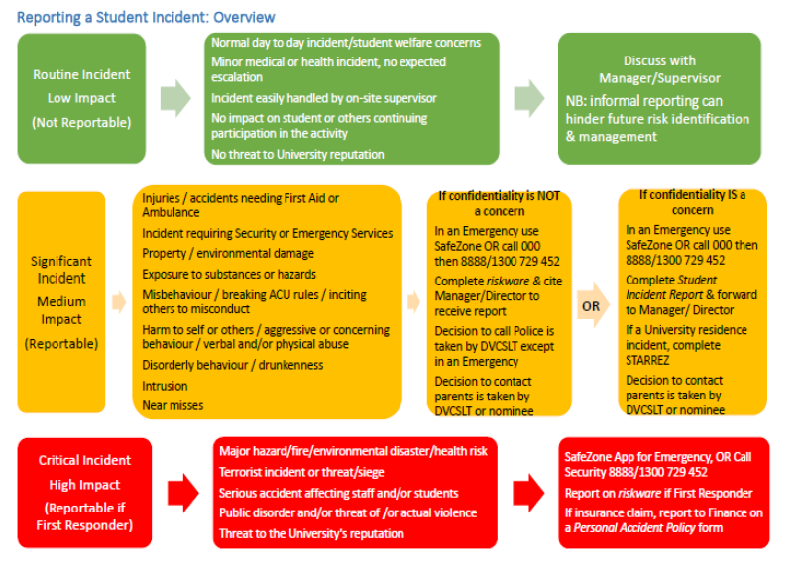

How to use this tool to Assess and Manage Risks Associated with the Event/Activity
Use this plan to assess the threats (something that could cause harm to people and/or property), listed within this Risk Assessment and Control Action Plan, for risk and develop treatments to manage these risks. During this process, consider consulting with subject matter experts to assess risk and develop treatments. You should also consult with anyone that would apply the treatments that are developed as these people will be responsible for implementing these actions.
Step 1: Assess each threat, which is listed in this plan, and enter any existing treatments (controls) that you apply to manage risk into column 4 (Page 4 to 9). The treatments that are listed in this plan should also include the actions that will be taken to mitigate the risk if the threat does occur.
Step 2: Assess the risk rating, using the Risk Rating Table in Appendix A, which is associated with applying these existing treatments to manage the risk.
The Risk Rating Table prompts you to assess the likelihood of the threat and consequence of the risk occurring. The intersection point between this likelihood and consequence rating = the Risk Rating for the threat.
Step 3: If the Risk of harm to people for a threat is higher than Medium (3) consider developing additional treatments to reduce the Risk Rating.
Step 4: Reassess the Risk Rating, based on applying existing and new treatments, and keep applying treatments until the risk is reduced down to a manageable level.
Step 5: In the last column, list the Action Owner that will be responsible for implementing the treatments.
Step 6: Submit the completed Risk Assessment and Control Action Plan to your Student Enrichment Advisor for endorsement and retain a copy for your records.
Step 7: Ensure that other people involved in overseeing aspects of the event are fully briefed about the risks identified and treatments and apply these strategies during the activity.
 | Threats |  |  | Risk Assessment |  |  | Action
Type | No. | What harm can happen to people or equipment? | List treatments that have already implemented |  | Describe what treatments, steps, strategies will be in place to reduce harm? | Risk Rating  (if the rating is higher than Moderate 3, apply more treatments to reduce the rating) | Action Required by Whom
Drunk & Disorderly | 1 | Drinking to excess that has caused intoxication | N/A No alcohol is being served |  |  | Moderate  3 | N/A
Drunk & Disorderly | 2 | Drink Spiking | N/A |  |  | Moderate  3 | N/A
 | Threats |  |  | Risk Assessment |  |  | Action
Type | No. | What harm can happen to people or equipment? | List treatments that have already implemented |  | Describe what treatments, steps, strategies will be in place to reduce harm? | Risk Rating  (if the rating is higher than Moderate 3, apply more treatments to reduce the rating) | Action Required by Whom
Property Damage | 3 | Damage to venue furniture | Student Life Officer will be present to supervise the musicians on arrival and will be available on mobile during the rehearsal times |  |  | Low  0.3 | Security will be on campus. If participant is found to have damaged furniture/property Security, Event Coordinators and ACU Staff are to control the situation and act to prevent reoccurrence and minimise danger if possible.  If necessary Student will be removed from event and ACU Staff to complete an incident report form.
Property Damage | 4 | Equipment risk and failure, trip hazard on equipment | Music equipment including 240V is safe and tagged & tested. Audience is not to walk on stage area, and all cables which are in movement areas for the musicians are to be taped down. |  |  |  | All equipment will be inspected by the musicians and Student Life Officer before the event commences. Any accidents will be documented and any injuries reported to Security and First Aid Officers.
Property Damage | 5 | Participation in criminal offence such as arson | Musician visitors will be briefed by Student Life as to locations of room and toilets and also out of bounds areas. |  |  | Low  0.3 | Security and ACU Staff will control the situation and ensure evacuation procedures are in place. If required they will contact emergency services.  Security and ACU Staff to use discretion as to whether a student needs to be removed from the event or detained in regard to a more serious offence requiring attendance by Police.  ACU Staff to contact National Manager, Student Experience. if emergency services are contacted.
Theft | 6 | Monies or valuables stolen from another person | N/A. No cash money or other valuables need to be present at the event. Musicians are responsible for securing their instruments |  |  | Low  0.09 | Security and ACU Staff to coordinate any allegations of theft and to use their discretion about what procedure needs to be followed based on the incident reported.
Motor Accident | 7 | Car Accident |  |  | N/A | N/A | N/A
Assault | 8 | Sexual Assault/Rape | The musicians are professional players and regularly perform together. |  |  | Moderate  0.9 | ACU Staff/Security to contact relevant Emergency Services in the event of an assault occurring and contact the National Manager, Student Experience.
Drugs | 9 | Identify possession of drugs | Individuals who are aware of persons at the venue who are engaged in unlawful drug-related activities or identify possession of drugs should advise Security. |  |  | Moderate  0.9 | Security and ACU Staff will use their discretion if possession of drugs has been identified and may ask student to leave the event or will contact the relevant emergency service.  The National Manager, Student Experience. will be contacted by the ACU Staff member.
Drugs | 10 | Use of Drugs | Individuals who are aware of persons at the venue who are engaged in unlawful drug-related activities or identify possession of drugs should advise Security. |  |  | Moderate  0.9 | Security and ACU Staff will use their discretion if drug usage has been identified and may ask student to leave the event or will contact the relevant emergency service.  The National Manager, Student Experience. will be contacted by the ACU Staff member.
 | Threats |  | Risk Assessment |  |  |  | Action
Type | No. | What harm can happen to people or equipment? | List treatments that have already implemented |  | Describe what treatments, steps, strategies will be in place to reduce harm? | Risk Rating  (if the rating is higher than Moderate 3, apply more treatments to reduce the rating) | Action Required by Whom
Suicide | 11 | Suicide attempts |  |  | The visiting group will be staying together and not isolating apart from toilet visits | Moderate  0.9 | Security and ACU Staff to take control of the situation and to contact emergency services dependant on the incident at hand to ensure the safety of the student and to ensure confidentiality as much as is possible.  National Manager, Student Experience to be notified by ACU Staff member.
Allergic Reaction | 12 | Reaction to food items | N/A |  |  | Moderate  0.9 | N/A
Natural Disaster | 13 | Weather | This is an indoor event |  |  | Low  0.3 | If an extreme weather event occurs Security and ACU Staff are to manage the students’ safety and evacuate the area. If required ACU Staff are to call the appropriate emergency services for assistance or information.
Natural Disaster | 14 | Extreme weather event e.g flood, bushfires | Event Coordinators and ACU Staff to monitor weather prior to and on the day of the event and advise on postponing event. |  |  | Moderate  0.9
Natural Disaster | 15 | Pandemic outbreak in country or world  e.g. COVID-19 | N/A |  |  | Moderate  3
Financial | 16 | Financial loss/fraud | This is a non ticketed no cash event |  |  | Low  0.09 | In the event of alleged theft Security and ACU Staff to take control of the situation and determine if emergency services are to be contacted.
Appendix A –Risk Rating Table How to calculate your risk score, using the scales in the table below:
Step 1: Assess the likelihood of the threat occurring (ratings between Rare to Almost Certain)
Step 2: Assess the likely consequence of the threat occurring (from Insignificant to Catastrophic)
Step 3: Identify the intersection point (on the table below) of the likelihood and consequence rating to obtain a Risk Rating.
Step 4: If the Risk Rating is higher than Medium (3) - especially if the threat could cause harm - continue to develop other treatments to reduce the risk.
Likelihood Ratings |  | Consequence Ratings
Almost Certain: Is expected to occur in most circumstances per month)  Likely: Will probably occur at least once (between once per month and once per year)  Moderate: Might occur at some time (between once per year and once in 5 years)  Unlikely: Could occur at some time (between once in 5 years and once in 20 years)  Rare: May occur in exceptional circumstances (once in more than 20 years) |  | Catastrophic: Could result in death, permanent total disabilities or severe injuries affecting multiple persons  Major: Could result in permanent partial disabilities or injuries or illness resulting in hospitalisation of multiple persons  Moderate: Could result in injury or illness resulting  Minor: Minor injury or illness  Insignificant: Unlikely to result in an injury
Likelihood  Rating  (values on vertical axis, below) | Consequence Rating Insignificant/Minor/Moderate/Major/Catastrophic)
Likelihood  Rating  (values on vertical axis, below) | (
Likelihood  Rating  (values on vertical axis, below) | Insignificant (1) | Minor (3) | Moderate (10) | Major (30) | Catastrophic (100)
Almost Certain  (3) | Moderate 3 | Moderate 9 | High 30 | High 90 | High 300
Likely  (1) | Moderate 1  1 | Moderate 3 | Moderate 10 | High 30 | High 100
Moderate  (0.3) | Low 0.3 | Moderate 0.9 | Moderate 3 | Moderate 9 | High 30
Unlikely  (0.1) | Low 0.1 | Low 0.3 | Moderate 1 | Moderate 3 | Moderate 10
Rare  (0.03) | Low 0.03 | Low 0.09 | Low 0.3 | Moderate 0.9 | Moderate 3

