|  |  |  |  |  |  |  |
| --- | --- | --- | --- | --- | --- | --- |
| **Student Life Campus and event name:** | | | | | | |
| Event | **Welcome Back day food truck / Red Bull car** | | Location | | | **Banyo campus main lawn** |
| Event Coordinator(s) | **Alastair Tomkins** | | Date &Time of Event | | | **Multiple dates in 2025** |
| Assessment Completed by | **Alastair Tomkins** | | Date prepared | | | **24/4/25** |
| **INCIDENT CONTACT LIST – In case of an emergency call 000 and notify staff at the event / call 8888 (ACU Campus Security) or 1300 729 452.**  **The Student Life Officer or staff member (present at the event) will notify the National Manager, Student Life.**  **If a staff member is not at the event, the Event Coordinator must contact the National Manager, Student Life.**  **In the case of any other incident that does not require emergency services, the local Student Life staff / event coordinator must report the matter to the National Manager, Student Life.** | | | | | | |
| **TITLE** | | **NAME** | | | **CONTACT NUMBER** | |
| Event Coordinator(s) | | **Alastair Tomkins** | | | **0412789132** | |
|  | | |  | |
| RSA Certificates – N.B. current certificate must be attached to the event request form | |  | | |  | |
|  | | |  | |
| Student Life Officer | | **Alastair Tomkins** | | | **0412789132** | |
| Campus Security | | **8888 (1300 729 452)** | | | | |
| First Aid Officer | | **8888 (1300 729 452)**  **or visit** [**http://www.acu.edu.au/policy/169133**](http://www.acu.edu.au/policy/169133) **to access staff First Aid Officers** | | | | |
| National Manager, Student Life- Student Support Services Directorate | | Alistair Cowie | | **0426 833 479** | | |
| Emergency Services, Fire Ambulance or Police | | Emergency | | **000** | | |
| **If Student Life Officer or National Manager Student Life cannot be contacted report Incident immediately to:**  **ACU National Security Centre (NSC) on 8888 or 1300 729 452** | | | | | | |

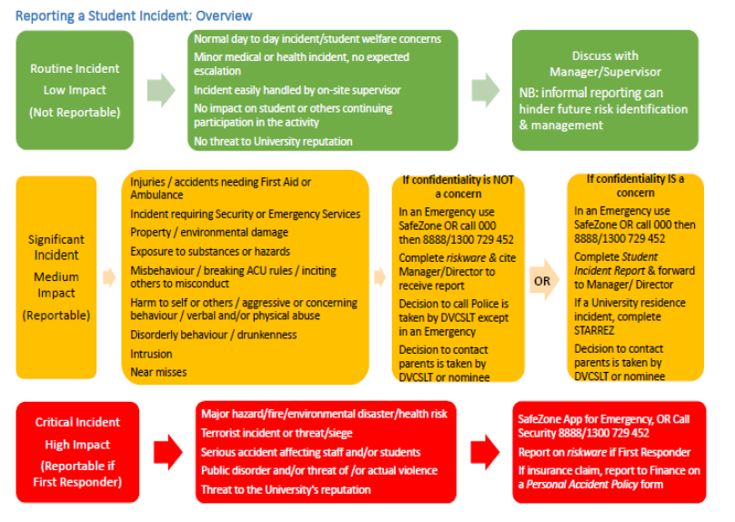

**How to use this tool to Assess and Manage Risks Associated with the Event/Activity**

Use this plan to assess the threats (something that could cause harm to people and/or property), listed within this Risk Assessment and Control Action Plan, for risk and develop treatments to manage these risks. During this process, consider consulting with subject matter experts to assess risk and develop treatments. You should also consult with anyone that would apply the treatments that are developed as these people will be responsible for implementing these actions.

Step 1: Assess each threat, which is listed in this plan, and enter any existing treatments (controls) that you apply to manage risk into column 4 (Page 4 to 9). The treatments that are listed in this plan should also include the actions that will be taken to mitigate the risk if the threat does occur.

Step 2: Assess the risk rating, using the Risk Rating Table in Appendix A, which is associated with applying these existing treatments to manage the risk.

The Risk Rating Table prompts you to assess the likelihood of the threat and consequence of the risk occurring. The intersection point between this likelihood and consequence rating = the Risk Rating for the threat.

Step 3: If the Risk of harm to people for a threat is higher than Medium (3) consider developing additional treatments to reduce the Risk Rating.

Step 4: Reassess the Risk Rating, based on applying existing and new treatments, and keep applying treatments until the risk is reduced down to a manageable level.

Step 5: In the last column, list the Action Owner that will be responsible for implementing the treatments.

Step 6: Submit the completed Risk Assessment and Control Action Plan to your Student Enrichment Advisor for endorsement and retain a copy for your records.

Step 7: Ensure that other people involved in overseeing aspects of the event are fully briefed about the risks identified and treatments and apply these strategies during the activity.

|  |  |  |  |  |  |  |  |
| --- | --- | --- | --- | --- | --- | --- | --- |
|  | **Threats** | |  | **Risk Assessment** | | | **Action** |
| Type | **No.** | **What harm can happen to people or equipment?** | **List treatments that have already implemented** | | **Describe what treatments, steps, strategies will be in place to reduce harm?** | **Risk Rating**  **(if the rating is higher than Moderate 3, apply more treatments to reduce the rating)** | **Action Required by Whom** |
| Property Damage | **1** | **Damage to venue furniture** | **Event Coordinators** will discuss venue setup requirements with the Campus Facilities Team prior to event to ensure the risk of damage to furniture is at a minimum. Appropriate rubbish and recycling bins are to be provided as confirmed with the Facilities Team.  The event is supervised by the **Event Coordinators, Security** and **ACU Staff**. | |  | Low  0.3 | If participant is found to have damaged furniture/property **Security, Event Coordinators** and **ACU Staff** are to control the situation and act to prevent reoccurrence and minimise danger if possible.  If necessary Student will be removed from event and ACU Staff to complete an incident report form. |
| Theft | **2** | **Monies or valuables stolen from another person** | The event is supervised by the **Event Coordinators, Security** and **ACU Staff**.  Students will come to the sample area in their break time and then move on to other locations or sit on the lawn. They will have their possessions with them during this time. | |  | Low  0.09 | **Security** and **ACU Staff** to coordinate any allegations of theft and to use their discretion about what procedure needs to be followed based on the incident reported. |
| Motor Accident | **3** | **Car Accident** | Food truck will phone Student Life officer before they enter and leave the main lawn. Vehicles will drive at walking pace <5 km/h with hazard lights on and with a spotter moving with the vehicles to look for any potential problems | |  | Moderate  3 | **ACU Staff/Security** to contact relevant **Emergency Services** in the event of an accident occurring and contact the National Manager, Student Experience. |
| Trip Hazards | **4** | **Trip Hazards** | Event space is set up with Student Life and the food truck depending on what they require. All leads and possible trip hazards from the equipment are to be identified before the performance commences and made safe by moving items away from audience walkways and/or taping down cables to minimise trip hazard potential. | |  | Moderate  3 | **Student Life Officer** to monitor area and make any necessary adjustments to equipment to minimise trip hazards. |
| Natural Disaster | **5** | **Weather** | **Event Coordinators** and **ACU Staff** to monitor weather prior to and on the day of the event. The outside courtyard is being used for this event so a backup plan will be organised with the Facilities Team to ensure the event will go ahead in the case of extreme weather or rain.  Safety of the students will be considered to ensure a last-minute change of venue is not required. | |  | Low  0.3 | If an extreme weather event occurs **Security** and **ACU Staff** are to manage the students’ safety and evacuate the area. If required ACU Staff are to call the appropriate emergency services for assistance or information. |
| **6** | **Extreme weather event e.g flood, bushfires** | **Event Coordinators** and **ACU Staff** to monitor weather prior to and on the day of the event and advise on postponing event. | |  |  |  |
| **14** | **Pandemic outbreak in country or world**  e.g. COVID-19 Virus in 2019/2020 worldwide | Worldwide Social lockdown  All face to face events to be cancelled and substituted with online events for the purpose of socialising, meeting for Professional Development or building community.  Social distancing laws implemented Australia wide so that no two people can come within 1.5m of each other. | | Need to safeguard against online hackers or unintended guests who might stalk, video stream or record these events.  Some students could be disruptive or disclose information to a wider group in this forum unintentionally.  Outsiders to ACU may get hold of link to event on social media pages and then attend unnoticed to stalk students.  Some online events could be wasted if too many people arrive and are not directed as to a plan or program for the event.  Copyright laws for streaming videos or music to be considered |  | Online platform chosen must have end to end encryption. Microsoft Teams and Zoom can provide this.  Student leader to remind student attendees to check that their camera is facing them and not revealing other things within their home space.  Providing students with a password to log into the meeting if possible or ensuring in the registration process that only current ACU students are invited and then provided with the log in details for the event. Promote only through ACU student email addresses or via **closed** student social media pages.  Students who organise these events must have the lead on the event and ensure that there is a focused agenda for the meeting or structured program to follow. Promotions can include a suggested program for the event. Students who chair the event should have a script /program to follow so that the online time flows and is successful. |

**Appendix A –Risk Rating Table How to calculate your risk score, using the scales in the table below:**

Step 1: Assess the likelihood of the threat occurring (ratings between Rare to Almost Certain)

Step 2: Assess the likely consequence of the threat occurring (from Insignificant to Catastrophic)

Step 3: Identify the intersection point (on the table below) of the likelihood and consequence rating to obtain a Risk Rating.

Step 4: If the Risk Rating is higher than Medium (3) - especially if the threat could cause harm - continue to develop other treatments to reduce the risk.

|  |  |  |  |
| --- | --- | --- | --- |
| **Likelihood Ratings** |  | **Consequence Ratings** |  |
| **Almost Certain:**  Is expected to occur in most circumstances per month)  **Likely:** Will probably occur at least once (between once per month and once per year)  **Moderate:** Might occur at some time (between once per year and once in 5 years)  **Unlikely:** Could occur at some time (between once in 5 years and once in 20 years)  **Rare:** May occur in exceptional circumstances (once in more than 20 years) | | **Catastrophic:** Could result in death, permanent total disabilities or severe injuries affecting multiple persons  **Major:** Could result in permanent partial disabilities or injuries or illness resulting in hospitalisation of multiple persons  **Moderate:** Could result in injury or illness resulting  **Minor:** Minor injury or illness  **Insignificant:** Unlikely to result in an injury | |

|  |  |  |  |  |  |
| --- | --- | --- | --- | --- | --- |
| **Likelihood**  **Rating**  **(values on vertical axis, below)** | **Consequence Rating Insignificant/Minor/Moderate/Major/Catastrophic)** | | | | |
| **(** | | | | |
| **Insignificant (1)** | **Minor (3)** | **Moderate (10)** | **Major (30)** | **Catastrophic (100)** |
| **Almost Certain**  **(3)** | **Moderate 3** | **Moderate 9** | **High 30** | **High 90** | **High 300** |
| **Likely**  **(1)** | **Moderate 1**  **1** | **Moderate 3** | **Moderate 10** | **High 30** | **High 100** |
| **Moderate**  **(0.3)** | **Low 0.3** | **Moderate 0.9** | **Moderate 3** | **Moderate 9** | **High 30** |
| **Unlikely**  **(0.1)** | **Low 0.1** | **Low 0.3** | **Moderate 1** | **Moderate 3** | **Moderate 10** |
| **Rare**  **(0.03)** | **Low 0.03** | **Low 0.09** | **Low 0.3** | **Moderate 0.9** | **Moderate 3** |