**THIS IS A LEGAL DOCUMENT AND MAY BE USED IN COURT IN THE EVENT OF AN INCIDENT OCURRING DURING YOUR ACTIVITY**

|  |  |  |  |  |  |  |
| --- | --- | --- | --- | --- | --- | --- |
| **STUDENT LIFE** | | | | | | |
| Event name & type | **Olympic watch sessions** | | Location | | | **Main lawn, 212 kitcehnette area** |
| Event Coordinator(s) | **Alastair Tomkins** | | Date &Time of Event | | | **10am-2pm Multiple dates in 2024 Sem 2 10am-2pm** |
| Event Manager(s) | **Alastair Tomkins** | |  | | |  |
| Assessment Completed by | **Alastair Tomkins** | | Date prepared | | | **23 January 2024** |
| **INCIDENT CONTACT LIST – In case of an emergency call 000 and notify staff at the event / call 8888 (ACU Campus Security) or 1300 729 452.**  **In the event of any incident the event manager will notify their supervisor. If they cannot contact their supervisor, they should contact the next person in the hierarchy.**  **If Student Life Officer or Student Life Manager cannot be contacted report Incident immediately to:**  **ACU National Security Centre (NSC) on 8888 or 1300 729 452** | | | | | | |
| **TITLE** | | **NAME** | | | **CONTACT NUMBER** | |
| Event Coordinator(s) | | **Alastair Tomkins** | | | **0412789132** | |
|  | | |  | |
|  | | |  | |
|  | | |  | |
| Designated non-drinker (if applicable) | | **N/A** | | |  | |
| Student Life Officer | | **Alastair Tomkins** | | | | |
| Event Security provided by (if applicable) | | **N/A** | | | | |
| First Aid Officer (if applicable) | | **N/A** | | | | |
| National Manager Student Life | | **Jodie Beckmann** | | **0455070924** | | |
| Emergency Services, Fire Ambulance or Police | | Emergency | | **000** | | |
| **If Student Life Officer or Student Life Manager cannot be contacted report Incident immediately to:**  **ACU National Security Centre (NSC) on 8888 or 1300 729 452** | | | | | | |

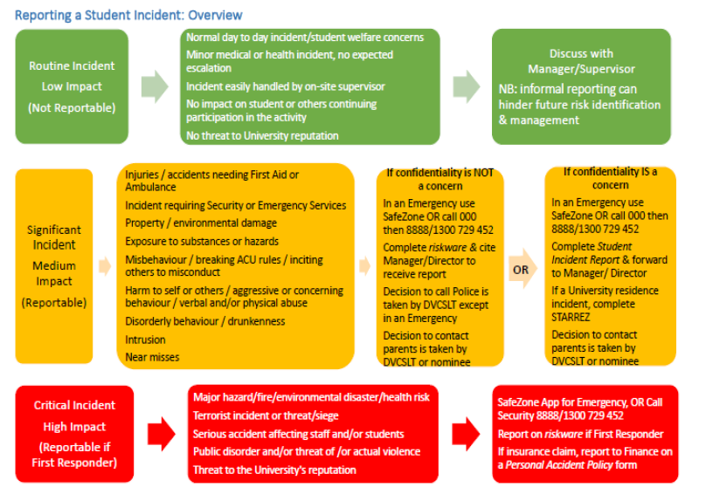

**How to use this tool to assess and manage risks associated with the event/activity**

Use this plan to assess the threats (i.e. something that could cause harm to people and/or property), listed within this Risk Assessment and Control Action Plan and develop treatments to manage these risks. During this process, consider consulting with subject matter experts to assess risk and develop treatments. You should also consult with anyone who might apply the treatments that are developed as they may be responsible for implementing the actions.

Step 1: Create a list of all the threats associated with your event. (Use the table on P5 to assist in this process).

Step 2. Transfer that list to Column 1 in the Risk Assessment and Control Action Plan Table (Page 6).

Step 3 Assess each threat listed in the plan and record any existing treatments (controls) that already apply to manage the risk into Column 3 of the Table. (Page 6). The treatments that are listed in this plan should also include the actions that will be taken to mitigate the risk if the threat does occur.

Step 4: Assess the risk rating, using the Risk Rating Matrix (Appendix A). The Matrix prompts you to assess the likelihood of the threat and consequence of the risk occurring. The intersection point between this likelihood and consequence rating = the Risk Rating for the threat.

Step 5: If the risk of harm to people for a threat is higher than Medium consider developing additional treatments to reduce the risk rating and add those to Column 5 of the Table (Page 6).

Step 6: Reassess the risk rating, based on applying existing and new treatments, and keep applying treatments until the risk is reduced down to a manageable level and enter the revised risk rating in Column 6 of the Table (Page 6).

Step 7: Submit the completed Risk Assessment and Control Action Plan to your supervisor for endorsement and retain a copy for your records.

Step 8: Ensure that other people involved in overseeing aspects of the event are fully briefed about the risks identified and treatments so that they may be applied during the activities.

When completing this section, you must give careful consideration to the actual nature of the event you are organising. The items mentioned in this section of the ACU Risk Assessment Form must be specific to the event with consideration to all likely risks.

**Risk Assessment and Control Action Plan Table**

|  |  |  |  |  |  |
| --- | --- | --- | --- | --- | --- |
| **Column 1** | **Column 2** | **Column 3** | **Column 4** | **Column 5** | **Column 6** |
| **Identified Risk** | **What harm can happen to people or equipment?** | **Pre-existing controls** | **Risk Rating** | **Additional action required (if rating falls in red zone)** | **Revised Risk Rating** |
| Damage to  property | **Damage to property** | All students agree to abide by the terms and conditions of the event which include appropriate behaviour per the Student Conduct and Discipline Policy.  Any students found to be causing damage to ACU equipment, furniture, premises or property will be removed from the event by security and be charged for the cost of repairs and / or reported to the police.  If any student is reported to the police for any matter, the National Manager must be called immediately. | **Low 2** |  |  |
| COVID | **Infection with the virus** | All ACU COVID 19 protocols to be observed as declared in the below links.  <https://www.acu.edu.au/emergency-and-safety/covid-19-resources/covid-protocol>  & <https://www.health.nsw.gov.au/Infectious/covid-19/Pages/default.aspx> | **Medium 6** |  |  |
| Sexual assault / harassment | **Sexual assault/harassment** | All event supervisors have attended and completed the ACU training in   * Risk assessment, * Critical Incident Framework and Reporting, * Student Sexual Misconduct Prevention and Response Policy, Bystander Awareness Training   This includes   * victim support * Code Green Procedures * NSC notification * manager notification   All students agree to abide by the terms and conditions of the event which include appropriate behaviour per the Student Conduct and Discipline Policy  In the event that any student is the victim of a sexual assault, evicted from the event for antisocial behaviour, or reported to the police for any matter, the National Manager must be called immediately. | **Medium 7** |  |  |
| Food | **Allergies to food items** | Food items include – cheese and crackers  Food items will have ingredients list available upon request. | **Medium 6** |  |  |
| Food | **Food safety** | Temperature sensitive items and perishables will be stored correctly according to package instructrions.  We will follow all relevant safe food handling instructions per: <https://dofoodsafely.health.vic.gov.au/index.php/en/> | **Low 1** |  |  |
| General event safety | **Security guards** | Normal campus security will be available for the duration of this event. | **Low 1** |  |  |

**Appendix A - Risk Assessment Matrix**

How to use the Risk Assessment Matrix.

Step 1: Assess the likelihood of the threat occurring (ratings between Rare to Almost Certain)

Step 2: Assess the likely consequence of the threat occurring (from Insignificant to Catastrophic)

Step 3: Identify the intersection point (on the table below) of the likelihood and consequence rating to obtain a Risk Rating.

Step 4: If the Risk Rating is higher than Medium (3) - especially if the threat could cause harm -continue to develop other treatments to reduce the risk

|  |  |  |  |  |  |  |  |
| --- | --- | --- | --- | --- | --- | --- | --- |
|  | | | **Potential Consequences** | | | | |
| **Not Significant:** Unlikely to result in an injury | **Minor:** Minor injury or illness | **Moderate:** Could result in injury or illness resulting in hospitalisation | **Major:** Could result in permanent partial disabilities or injuries or illness resulting in hospitalisation of multiple persons | **Severe:** Could result in death, permanent total disabilities or severe injuries affecting multiple persons |
| **Not Significant** | **Minor** | **Moderate** | **Major** | **Severe** |
| **Likelihood** | Expected to occur regularly under normal circumstances | **Almost**  **Certain** | **Medium 4** | **Medium 5** | **Very High 9** | **Very High 10** | **Very High 11** |
| Expected to occur at some time | **Likely** | **Medium 4** | **Medium 5** | **Medium 6** | **Very High 10** | **Very High 11** |
| May occur at some time | **Possible** | **Low 1** | **Medium 5** | **Medium 6** | **Medium 7** | **Very High 11** |
| Not likely to occur in normal circumstances | **Unlikely** | **Low 1** | **Low 2** | **Medium 6** | **Medium 7** | **Medium 8** |
| Could happen, but probably never will | **Rare** | **Low 1** | **Low 2** | **Low 3** | **Medium 7** | **Medium 8** |