|  |  |  |  |  |  |  |
| --- | --- | --- | --- | --- | --- | --- |
| **STUDENT LIFE – OFFICE OF STUDENT SUCCESS** | | | | | | |
| Event name & type | **Social Work Society Drop Ins** | | Location | | | **Level 1 Veritas Building 301** |
| Event Coordinator(s) | **Rebecca McMillan** | | Date &Time of Event | | | **Tuesdays 12-1:30, dates as indicated in event plan** |
| Event Manager(s) |  | |  | | |  |
| Assessment Completed by | **Kristen Bosio** | | Date prepared | | | **05/03/2024** |
| **INCIDENT CONTACT LIST – In case of an emergency call 000 and notify staff at the event / call 8888 (ACU Campus Security) or 1300 729 452.**  **In the event of any incident the event manager will notify their supervisor. If they cannot contact their supervisor they should contact the next person in the hierarchy.**  **If Student Life Officer or Student Life Manager cannot be contacted report Incident immediately to:**  **ACU National Security Centre (NSC) on 8888 or 1300 729 452** | | | | | | |
| **TITLE** | | **NAME** | | | **CONTACT NUMBER** | |
| Event Coordinator(s) | | **Kristen Bosio** | | | **0409464568** | |
| **Rebecca McMillan** | | | **0438619821** | |
|  | | |  | |
|  | | |  | |
| Student Life Officer | | **Thomas Cressy** | | | **0433769944 - 0262091277** | |
| Event Security provided by (if applicable) | | N/A event during business hours, regular Campus first aid officers available  **Campus Security 8888 (1300 729 452)** and event coordinator has SafeZone app | | | | |
| First Aid Officer (if applicable) | | N/A event during business hours, regular Campus first aid officers available  **First Aid Officer 8888 (1300 729 452)** and event coordinator has SafeZone app | | | | |
| Designated non-drinker (if applicable) | | N/A | | | | |
| National Manager Student Life | | **Jodie Beckham** | | **0455 070 227** | | |
| Emergency Services, Fire Ambulance or Police | | Emergency | | **000** | | |
| **If Student Life Officer or Student Life Manager cannot be contacted report Incident immediately to:**  **ACU National Security Centre (NSC) on 8888 or 1300 729 452** | | | | | | |

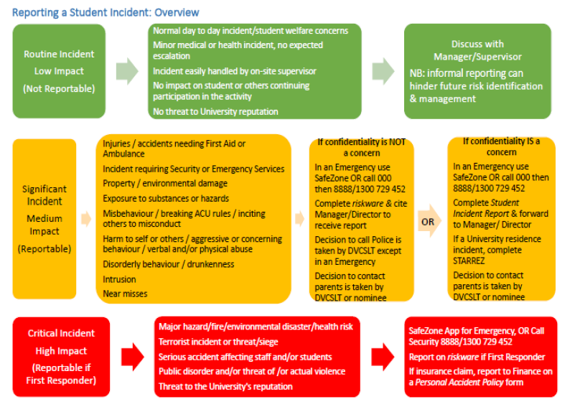

**How to use this tool to assess and manage risks associated with the event/activity**

Use this plan to assess the threats (i.e. something that could cause harm to people and/or property), listed within this Risk Assessment and Control Action Plan and develop treatments to manage these risks. During this process, consider consulting with subject matter experts to assess risk and develop treatments. You should also consult with anyone who might apply the treatments that are developed as they may be responsible for implementing the actions.

Step 1: Create a list of all the threats associated with your event. (Use the table on P5 to assist in this process).

Step 2. Transfer that list to Column 1 in the Risk Assessment and Control Action Plan Table(Page 6).

Step 3 Assess each threat listed in the plan and record any existing treatments (controls) that already apply to manage the risk into Column 3 of the Table. (Page 6). The treatments that are listed in this plan should also include the actions that will be taken to mitigate the risk if the threat does occur.

Step 4: Assess the risk rating, using the Risk Rating Matrix (Appendix A). The Matrix prompts you to assess the likelihood of the threat and consequence of the risk occurring. The intersection point between this likelihood and consequence rating = the Risk Rating for the threat.

Step 5: If the risk of harm to people for a threat is higher than Medium consider developing additional treatments to reduce the risk rating and add those to Column 5 of the Table (Page 6).

Step 6: Reassess the risk rating, based on applying existing and new treatments, and keep applying treatments until the risk is reduced down to a manageable level and enter the revised risk rating in Column 6 of the Table (Page 6).

Step 7: Submit the completed Risk Assessment and Control Action Plan to your supervisor for endorsement and retain a copy for your records.

Step 8: Ensure that other people involved in overseeing aspects of the event are fully briefed about the risks identified and treatments so that they may be applied during the activities.

**Things to consider**

These are just thought starters… you should consider what might go wrong at any stage of every event.

|  |  |
| --- | --- |
| * Location / Environmental factors   + Drowning (e.g. harbour cruises, swimming parties)   + Sunburn / heatstroke   + Falling (e.g. roof top bars)   + Getting lost (e.g. bush walks)   + Fires (e.g. BBQs, camping trips) | * Alcohol / Drugs   + Underage   + RSA   + Intox   + Possession |
| * Weather   + Rain   + Wind   + Temp extremes   + Floods | * Personal Injury / sexual harassment / sexual assault   + Trips and falls   + Assaults   + First aid on hand |
| * Financial   + Not selling enough tickets   + Sponsorship   + Theft | * Equipment failure   + Keg systems   + Jumping castles   + Slushie machines   + Smoothie Bikes |
| * Catering   + Food safety   + Not enough food / drink   + Food poisoning   + Allergies | * Damage to equipment / facilities   + By participants (e.g. cricket match breaks window)   + By activities (e.g. mental health puppies dig up Quad) |
| * Ticketing Ts&Cs…e.g….   + *Student Life practices zero tolerance of unruly behaviour and the event coordinators will ensure that any behaviour of this nature is reported. Failure to comply with these measures may result in the student been not able to attend other ACU events.*   + *Criminal activity will not be tolerated and will result in police been called.* | * Staff / volunteers   + don’t turn up   + inadequately trained/prepared |

**Risk Assessment and Control Action Plan Table**

|  |  |  |  |  |  |
| --- | --- | --- | --- | --- | --- |
| **Column 1** | **Column 2** | **Column 3** | **Column 4** | **Column 5** | **Column 6** |
| **Identified Threat** | **What harm can happen to people or equipment?** | **List treatments that have already been implemented** | **Risk Rating** | **Additional action required (if event falls in Orange or Red zones)** | **Revised Risk Rating** |
| Psychological Safety – antisocial behaviour leading to exclusion of others | Creation of a hostile environment  Individuals may feel unwelcome or unsafe | Having Society officers in attendance.  Brief introduction by Society officer about rules and group expectations  If the expectations are not met, talking with the individual, giving a warning, and reminding them of the expectations. | Low |  |  |
| Food Poisoning / Illness related to ingestion of food. | Food poisoning illness due to spoiled or inappropriately stored food  Choking hazards | Event Coordinator will have Food Safety Certificate (attached below).  Food will be kept indoors under appropriate temperatures.  Food will be purchased at the relevant date and ensure that food will not be spoiled or past the used / best by date.  Campus First Aid Officers for choking are available and contactable by SafeZone App or 8888 | Low |  |  |
| Allergies to food items | Allergic reactions to food items which could be mild to severe. | Food will be labelled with all ingredients and this will be easily available to all attendees.  Foods with high probability of allergens will be avoided. (Nuts etc).  Food will be stored and split according to type. (e.g apples sperate from oranges, gluten-free from not.)  Sanitiser and napkins will be available for students to utilise before taking any food. | Low |  |  |
| Property damage | ACU property being misused  ACU property being broken | Society officers present at all times to supervise  Asking anyone misusing equipment to leave the space | Low |  |  |
| Injury due to falls, tripping or equipment misuse | Tripping or falling injuries  Bumps or bruises  Potential head injury from fall or furniture | The space will be set up so it is tidy and free of clutter on the floor before the group starts  The furniture being used is easy to walk around and has a clear path  Equipment is required to be set-up according to OH&S principals. [Managing and preventing WHS Risks.](https://staff.acu.edu.au/people_and_capability/your-safety-and-wellbeing/work-health-and-safety-management-system) | Low |  |  |
| Fire –  Fire could start in the building due to residential upstairs, student kitchenette, electrical fires etc | Burns  Smoke inhalation | Event coordinator to know where the emergency exits are and location of nearest fire alarm button  Event coordinator to know the emergency meeting up point | Low | ACU Staff will control the situation and ensure evacuation procedures are in place. If required they will contact emergency services. |  |
|  |  |  |  |  |  |
|  |  |  |  |  |  |

**Appendix A - Risk Assessment Matrix**

How to use the Risk Assessment Matrix.

Step 1: Assess the likelihood of the threat occurring (ratings between Rare to Almost Certain)

Step 2: Assess the likely consequence of the threat occurring (from Insignificant to Catastrophic)

Step 3: Identify the intersection point (on the table below) of the likelihood and consequence rating to obtain a Risk Rating.

Step 4: If the Risk Rating is higher than Medium (3) - especially if the threat could cause harm -continue to develop other treatments to reduce the risk

|  |  |  |  |  |  |  |  |
| --- | --- | --- | --- | --- | --- | --- | --- |
|  | | | **Potential Consequences** | | | | |
| **Not Significant:** Unlikely to result in an injury | **Minor:** Minor injury or illness | **Moderate:** Could result in injury or illness resulting in hospitalisaiton | **Major:** Could result in permanent partial disabilities or injuries or illness resulting in hospitalisation of multiple persons | **Severe:** Could result in death, permanent total disabilities or severe injuries affecting multiple persons |
| **Not Significant** | **Minor** | **Moderate** | **Major** | **Severe** |
| **Likelihood** | Expected to occur regularly under normal circumstances | **Almost**  **Certain** | **Medium** | **High** | **Very High** | **Very High** | **Very High** |
| Expected to occur at some time | **Likely** | **Medium** | **High** | **High** | **Very High** | **Very High** |
| May occur at some time | **Possible** | **Low** | **Medium** | **High** | **High** | **Very High** |
| Not likely to occur in normal circumstances | **Unlikely** | **Low** | **Low** | **Medium** | **Medium** | **High** |
| Could happen, but probably never will | **Rare** | **Low** | **Low** | **Low** | **Low** | **Medium** |

**